Lab Program 3:

Create a class Book which contains four members: name, author, price, num_pages. Include a constructor to set the values for the members. Include methods to set and get the details of the objects. Include a toString( ) method that could display the complete details of the book. Develop a Java program to create n book objects.

CODE:

import java.util.*;

class Book{

Scanner sc = new Scanner(System.in);

String name;

String author;

int price;

int num_pages;

Book()

{

System.out.println("Enter book name");

name = sc.next();

System.out.println("Enter author name");

author = sc.next();

System.out.println("Enter number of pages");

num_pages = sc.nextInt();

System.out.println("Enter price");

price = sc.nextInt();

}

void set()

{

System.out.println("All inputs are set");

}

void get()

{

System.out.println("The details of the book are" + name + " " + author + " " + num_pages + " " + price);

}

public String toString()

{

return name + " " + author + " " + num_pages + " " + price;

}

}

class Main

{

public static void main(String args[])

{

int r,i;

System.out.println("Enter number of books");

Scanner sc = new Scanner(System.in);

r = sc.nextInt();

Book b[] = new Book[r];

for(i = 0;i<r;i++)

{

b[i] = new Book();

b[i].set();

b[i].get();

}

for(i = 0;i<r;i++)

{

System.out.println(b[i]);

}

}

}

WRITTEN CODE:

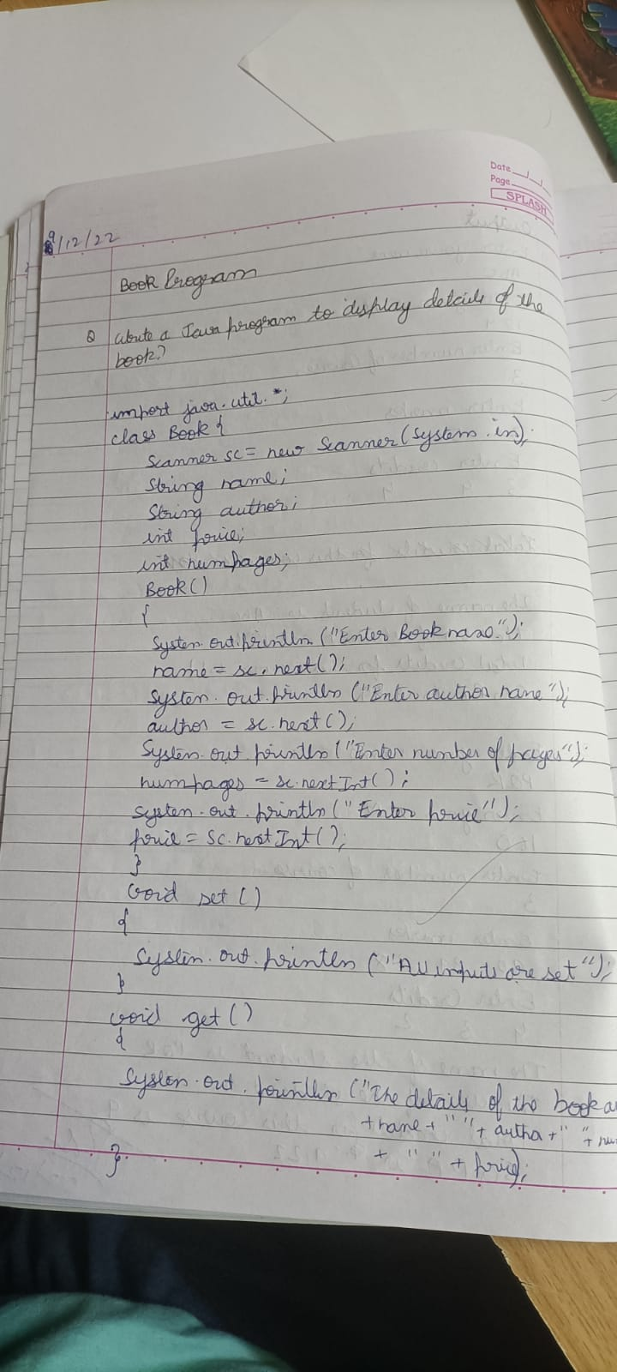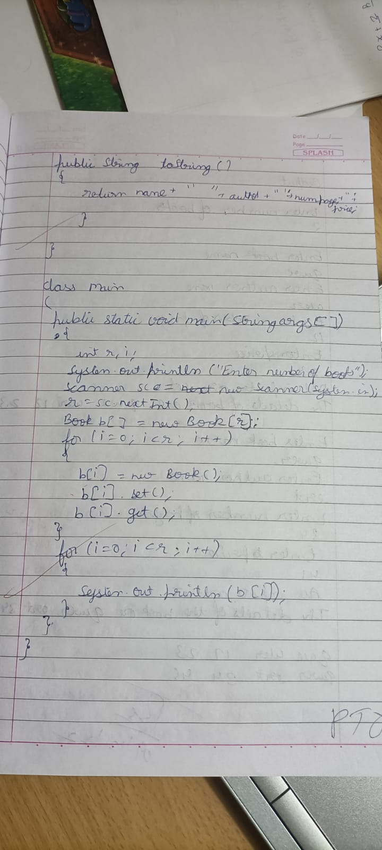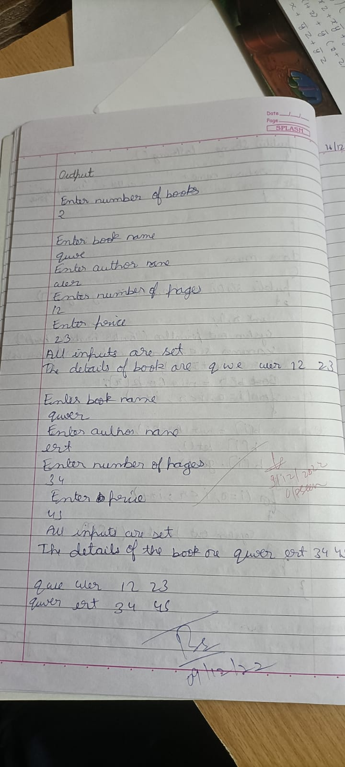

OUTPUT:

